9DT Electric Push Cart Parameter Table
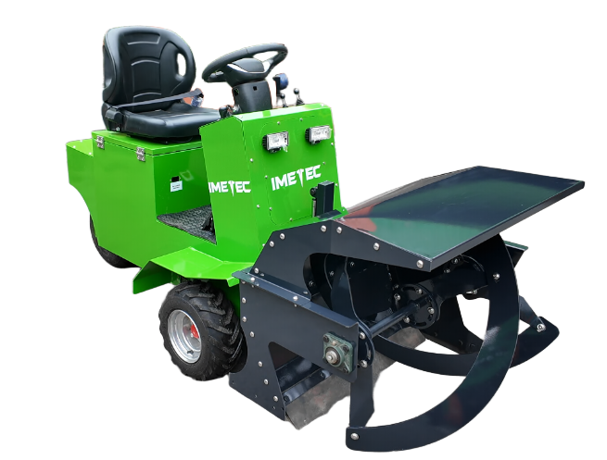
name | parameter
move  force  department  point | Model Specifications | 9DT - 60V
move  force  department  point | brand | IMETEC
move  force  department  point | Vehicle model | self made
move  force  department  point | Drive form | Front-wheel drive
move  force  department  point | Whole machine transmission method | Hydraulics
move  force  department  point | walking style | pure electric
move  force  department  point | Walking motor power | 72V1000W
move  force  department  point | Steering form | Rear Steering
move  force  department  point | Number of tires | 3
move  force  department  point | Tire Model | Rear steering wheels 18*9.50-8; Front drive wheels 6.50-8
move  force  department  point | Material pushing method | push plate
move  force  department  point | Push plate operation method | Manual hydraulic valve
move  force  department  point | Does it include cleaning? | no
move  force  department  point | Multi-way valve model | ZT-12E-OT-40
move  force  department  point | Hydraulic system | Independent hydraulic power unit
move  force  department  point | Number of hydraulic cylinders | 2
move  force  department  point | Hydraulic cylinder specifications | 60*42/60*47
move  force  department  point | Battery brand and capacity | Export lithium battery 100Ah
move  force  department  point | Battery voltage | 60V
move  force  department  point | Number of batteries in the whole machine | 1
move  force  department  point | Charging time | 8-10 hours
move  force  department  point | Battery life | 6-8 hours
move  force  department  point | Overall dimensions | 2100*1350*1400mm

